## **How Toggles Work in Streamline**

**In this article, you will learn about:**

What are Toggles?

Configuring the True Response

Configuring the False Response

Configuring Default Properties

A Very Important Note!!!

Adding a Violation to Appear on an Inspection Report

Making a Violation a Self-Certification Violation

### What are Toggles?

* A toggle is a control found in Checklists to create Streamline inspection questions.

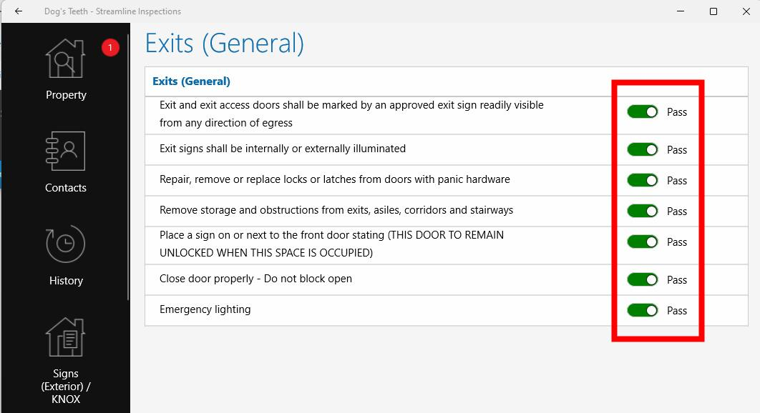

* 1. It allows the inspector to input a True/False, Pass/Fail, or Yes/No answer to the question.
  2. The toggle also instructs Streamline to carry out a series of actions associated with the answer.
* The inspection questions that the inspector sees on his tablet are constructed and configured inside a Checklist in Streamline Admin.

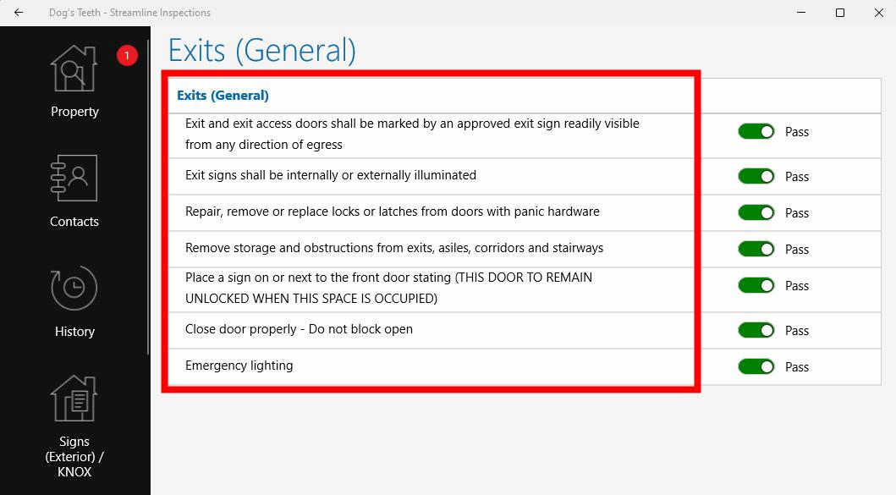

* When configuring a toggle, you will see the following controls.

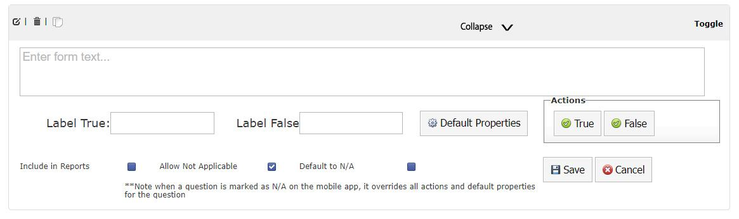

* 1. First, uncheck the “Default to N/A” box so that the question will be visible on the tablet.
  2. Enter the text to appear on the inspection in the “Enter form text…” box. For example, if you want the inspector to answer the question, “Did a licensed electrician perform the work?” you would enter that wording in the ‘Enter form text . . .” box.
  3. Enter text in the Label True and Label False boxes to provide the answers to the question.
     1. If you want the True answer to be “Yes,” enter it here. You can enter “Yes,” or “Pass” or “True” or any answer you choose in the Label True box. This is the answer that will appear on the question when the inspector performs the inspection.
     2. You can also enter any opposite answer in the Label False box.
  4. If you want the question to appear on the inspection report, check the “Include in Reports” checkbox. Checking this box will allow the customer to see this question and the answer.

### Configuring the True Response

* **First, provide the settings for a “Yes” response.”** 
  1. Click the True Action button to set the behavior of a “True/Yes” response. By configuring the settings in True Actions, you are telling Streamline what actions you want it to perform when the inspector answers “True/Yes.”
  2. Click the Properties tab at the top of the window.

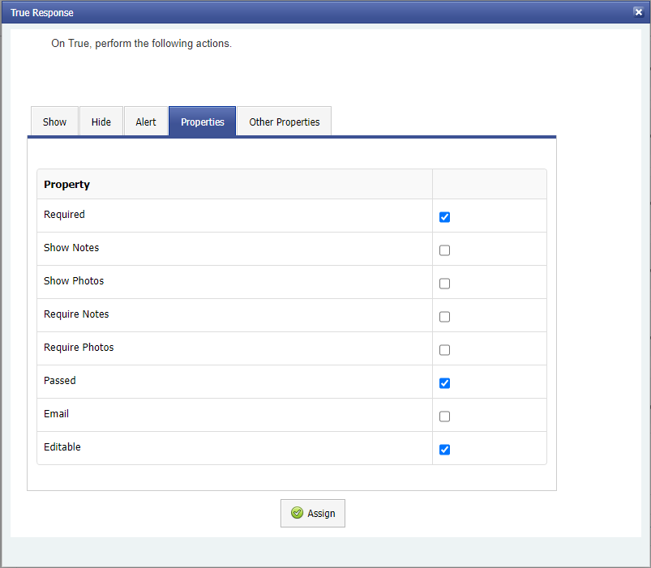

* + 1. You will almost always want to check the “Editable” box. Editable means that the inspector is allowed to interact with the question and provide an answer.
    2. You will also almost always want to check the “Passed” box on a “True/Yes” response. “Passed” means that the answer to the question is “True/Yes.” Checking the Passed box also tells Streamline not to issue a violation if a code violation is associated with the question.

#### You can control the question’s text color with the “Required” checkbox.

* + - 1. If “Required” is checked in both “True Action” and “Default Properties” AND “Passed” is checked in True Action too, the text will appear green when the toggle is in the “True/Yes” position.
      2. To display the question’s text in red, check “Required” in both “True Action” and “Default Properties” and uncheck “Passed” in True Action. (As you will see later, the same procedure applies for False Properties settings.)

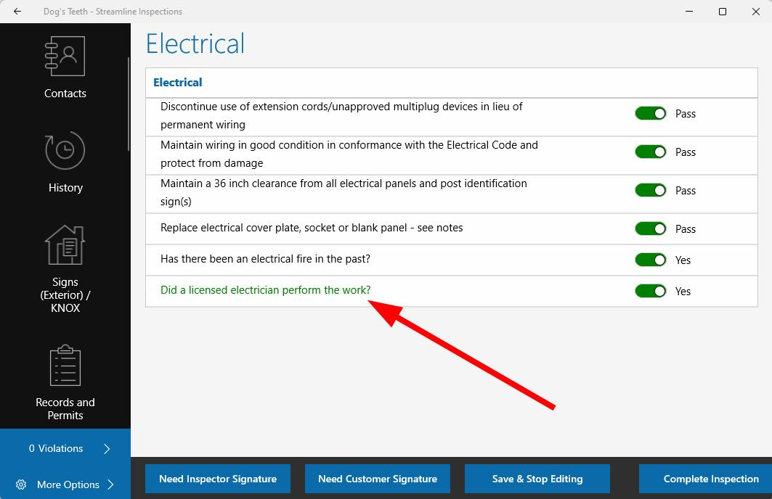

* + 1. Require Notes & Require Photos
       1. Checking “Require Notes” will require the inspector to enter a note on a “True/Yes” response.
       2. Checking “Require Photos” will require the inspector to capture a photo.
       3. A red number will appear in the tab on the left side of the screen corresponding to the section that contains a question that requires notes or requires photos. For instance, if a question in the Electrical section of the inspection requires notes or photos, a red number will appear next to the Electrical tab to indicate the number of actions that are required here. You will not be able to complete the inspection until these actions are complete.

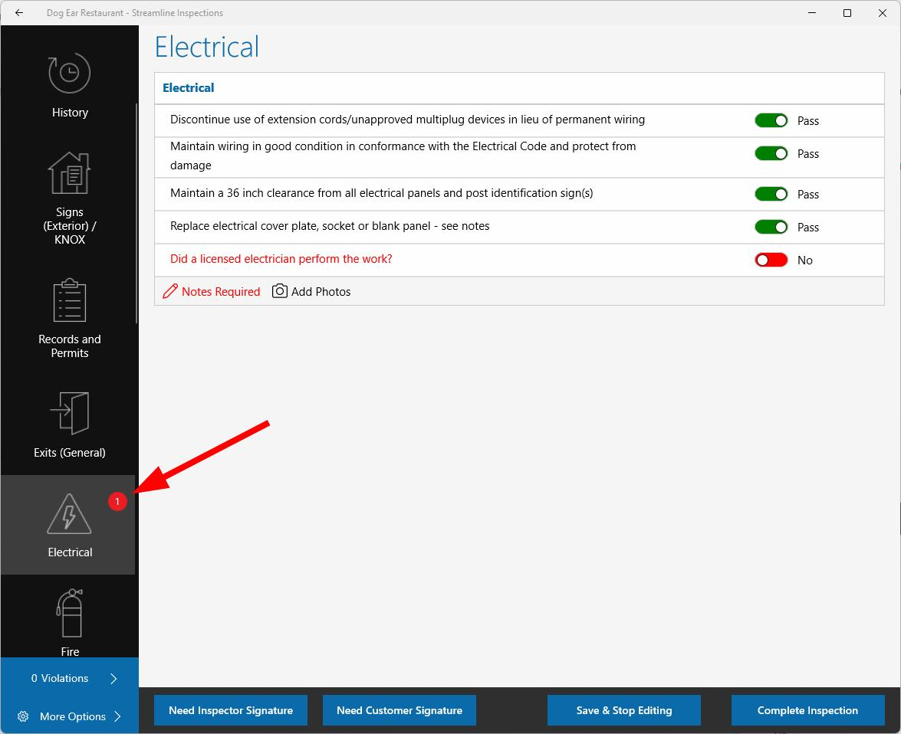

* + - 1. Generally, the “Require Notes” and “Require Photos” checkboxes are selected on a “Fail/No” response.
    1. Show Notes & Show Photos
       1. “Show Notes” will show the note that the inspector entered on the tablet beneath the question.

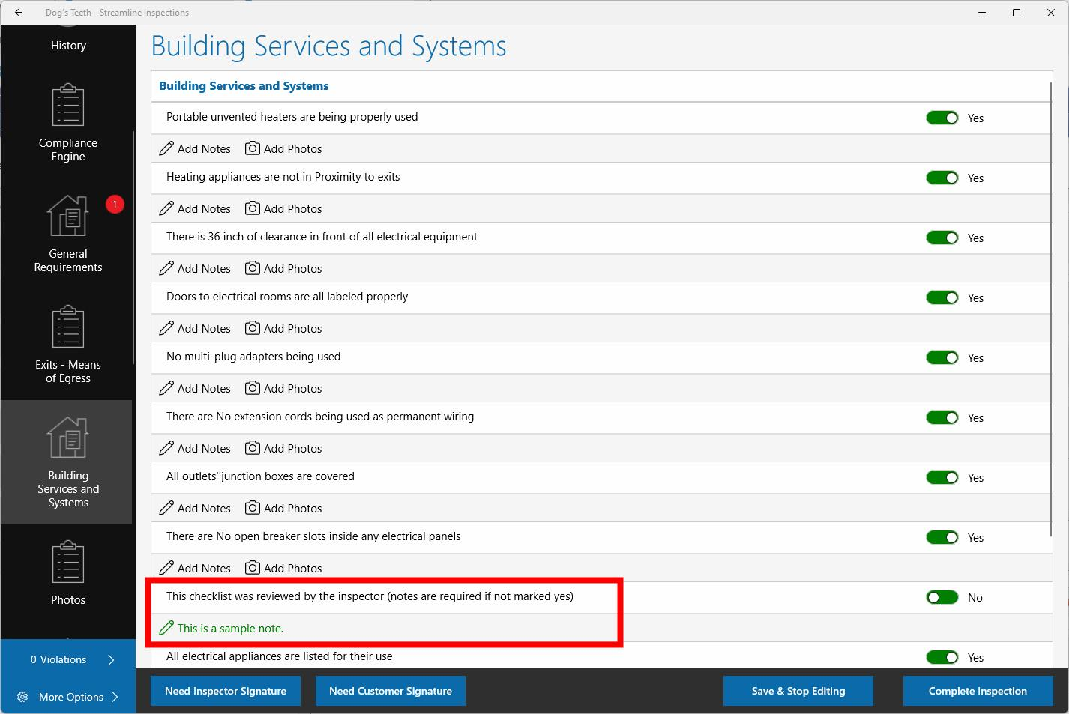

* + - 1. “Show Photos” will show photos in the “Photos” link under the question.
    1. Checking the “Email” checkbox will cause Streamline to send an email on a True/Yes response. An email will be sent to the address listed in the Email Templates tab under the Admin tab in the Admin portal.
    2. Note: Most of the time, “Require Notes, Show Notes, Require Photos, Show Photos, and Email” are not used in the True Actions settings. They are often checked in “False Actions” settings because further actions are needed for a “No/Fail” response.
  1. The “Show” and “Hide” tabs can be used to show and hide additional questions based upon a true response.
     1. Once you have created more questions in the current checklist, questions will appear in the Show and Hide tabs.
     2. If no additional questions appear, no additional questions exist in this checklist.
  2. Other Properties: This area allows the user to set the behavior for other questions on a “True/Yes” response. (I.e. If an additional question is set to “show” on a “Yes” response, the user can designate another question as “Required” or to “Require Notes,” etc…).

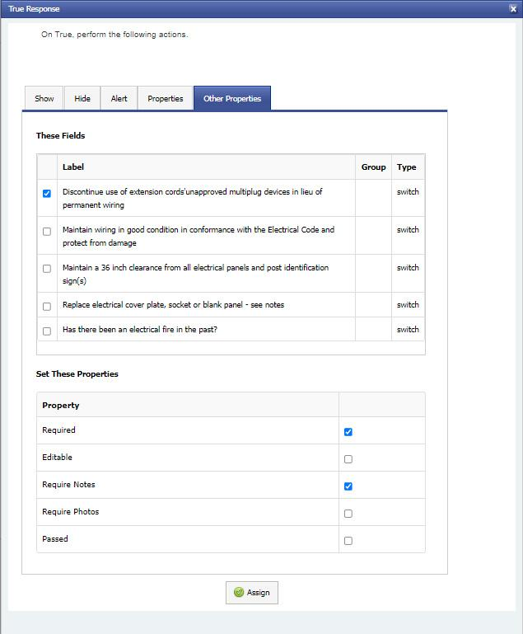

* 1. Alert tab: Entering text in the Alert tab text box will trigger an alert message that will appear on the inspector’s tablet when answering this question.
     1. If text is entered in the Alert tab in True Actions properties, the alert will appear when the inspector answers “True/Yes.”
     2. Conversely, if text is entered in the Alert tab in False Actions properties, the alert will appear when the inspector answers “False/No.”

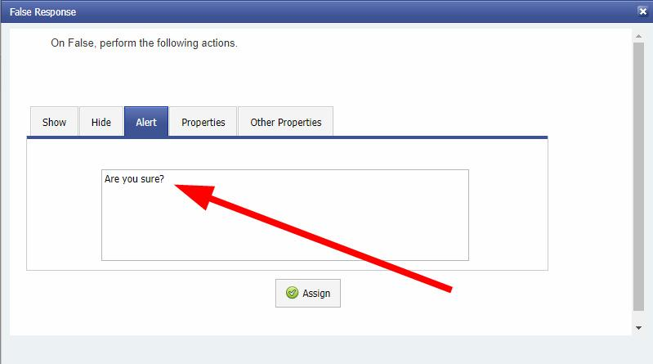

* + 1. For instance, enter, “Are you sure?” to prompt the inspector to think twice about their response.

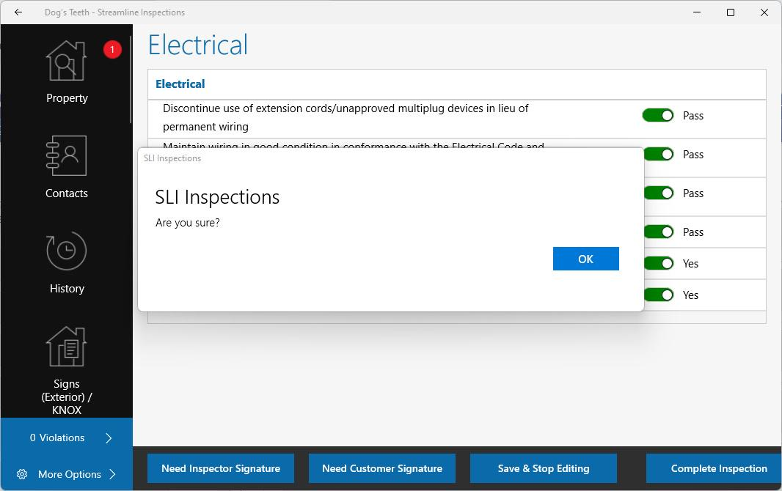

* 1. Once you have entered all the necessary information in the “True Actions” settings, click “Assign” to save.

### Configuring the False Response

* **Second, provide the settings for a “No” response.”** 
  1. Click the “False Action” button to set the behavior of a “False/No” response. By configuring the settings in False Actions, you are telling Streamline what actions you want Streamline to perform when the inspector answers “False/No.”
  2. You will notice that the pop up window for “False Actions” contains the same Controls as for “True Actions.”
  3. Click the Properties tab at the top of the window.

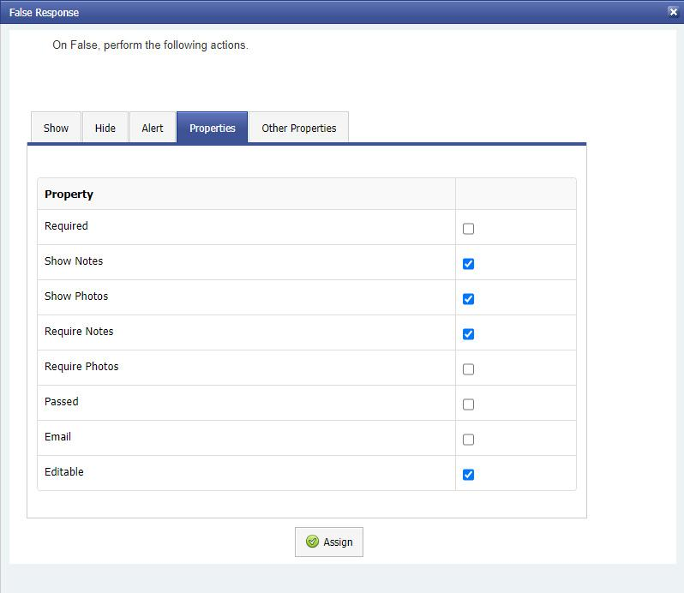

* + 1. You will almost always want to check the “Editable” box. Editable means that the inspector is allowed to interact with the question and provide an answer.
    2. For a “Fail/No” answer, you will also almost always want to uncheck the “Passed” box since a checked “Passed” box means that the answer to the question is “True/Yes.”
       1. Unchecking the “Passed” box also instructs Streamline to issue a violation on a “Fail/No” answer if a code violation is associated with the question. You will designate the violation later in Default Properties.
       2. Unchecking the “Passed” box will also change the color of the toggle to red on a “Fail/No” response.

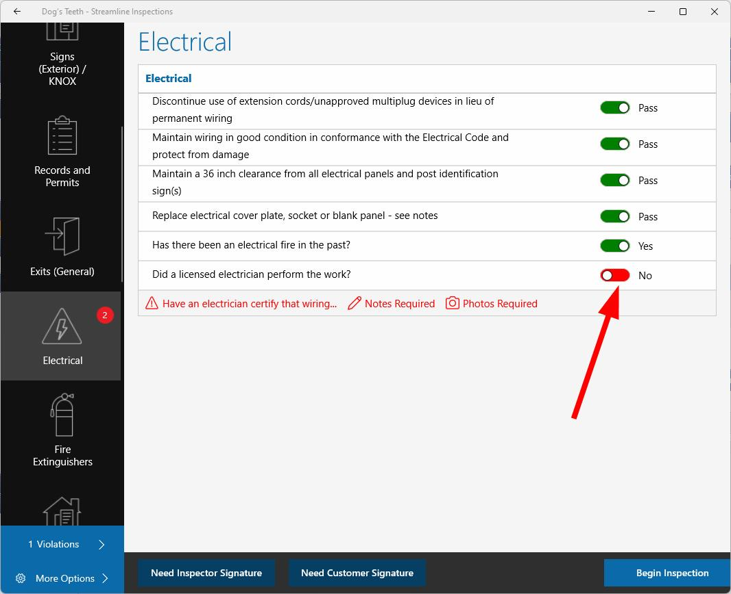

#### You can control the question’s text color with the “Required” checkbox.

* + - 1. If “Required” is checked in both “False Action” and “Default Properties” AND “Passed” is unchecked in False Action too, the text will appear red when the toggle is in the “Fail/No” position.

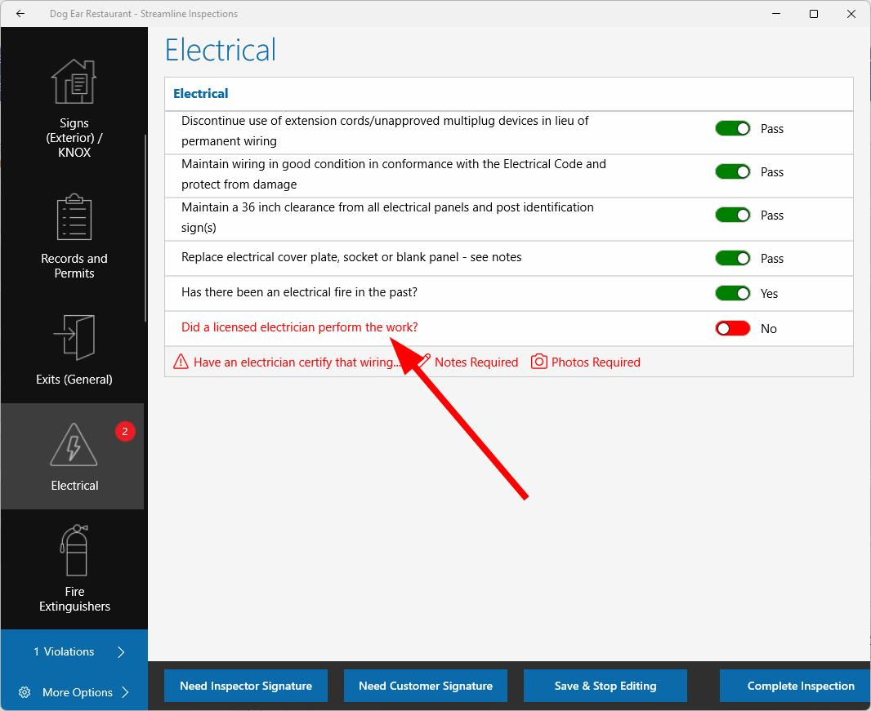

* + - 1. To display the question’s text in green, check “Required” in both “True Action” and “Default Properties” and check “Passed” in False Action.
    1. Require Notes & Require Photos
       1. “Require Notes” will require the inspector to enter a note on a True/Yes response.
       2. “Require Photos” will require the inspector to capture a photo.
       3. A red number will appear in the tab on the left side of the screen corresponding to the section that contains a question that requires notes or requires photos. For instance, if a question in the Electrical section of the inspection requires notes or photos, a red number will appear next to the Electrical tab to indicate the number of actions required in this section. You will not be able to complete the inspection until these actions are complete.
    2. Show Notes and Show Photos
       1. “Show Notes” will show the note that the inspector entered on the tablet beneath the question.



* + - 1. “Show Photos” will show photos in the “Photos” link under the question.
    1. Checking the “Email” box will send an email on a “Fail/No” response. An email will be sent to the address listed in the Email Templates tab under the Admin tab in the Admin portal.
    2. Note: When one or more of “Require Notes, Show Notes, Require Photos, Show Photos, and Email” are checked, it is usually because of a “Fail/No” answer.
* The “Show” and “Hide” tabs can be used to show and hide additional questions based upon the “False/No” response.
  1. Questions will appear in these tabs after you have created more questions in the same checklist.
  2. If no additional questions appear, no additional questions exist in this checklist.
* Other Properties: This tab allows you to configure the behavior for other questions that have been triggered by the response to this question. (I.e. If an additional question is set to “show” on a “No” response, the user can designate another question as “Required” or to “Require Notes,” etc…).
* Alert tab: Entering text in the Alert tab text box will trigger an alert message that will appear on the inspector’s tablet when answering this question.
  1. If text is entered in the Alert tab in True Actions properties, the alert will appear when the inspector answers “True/Yes.”
  2. Conversely, if text is entered in the Alert tab in False Actions properties, the alert will appear when the inspector answers “False/No.”
  3. For instance, enter, “Are you sure?” to prompt the inspector to think twice about their response.

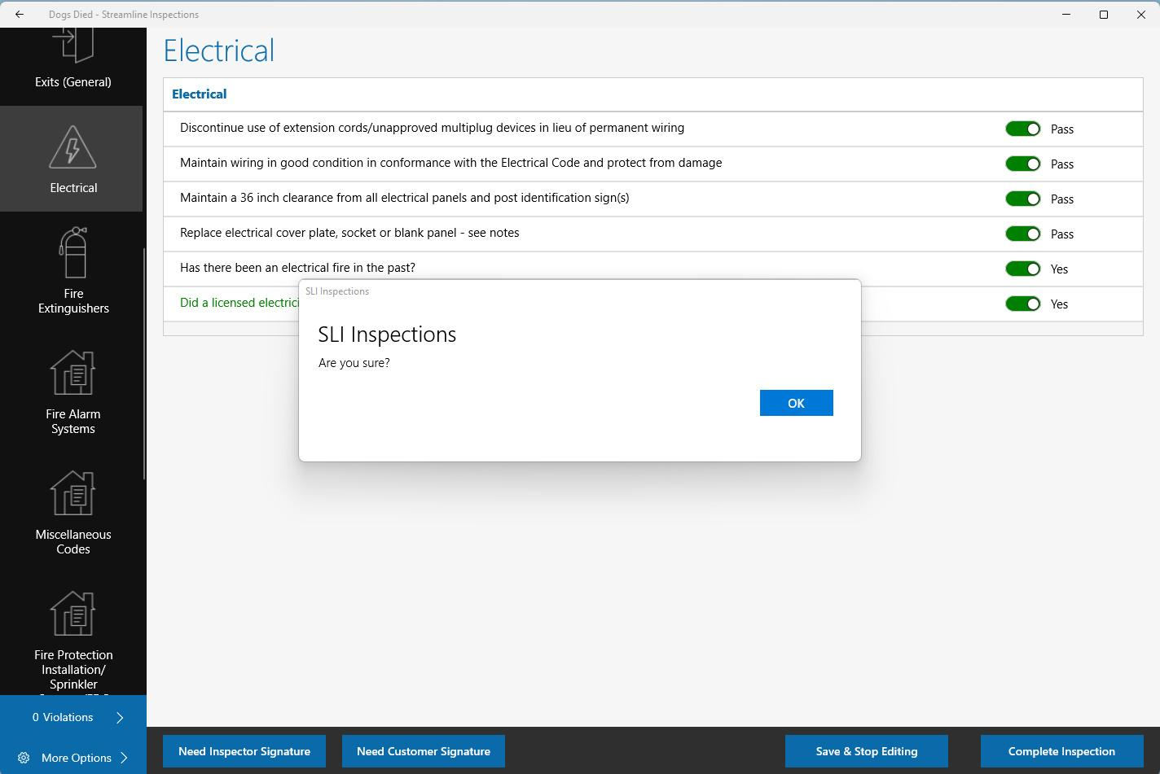

* 1. Once you have entered all the necessary information in the “True Actions” settings, click “Assign” to save.

### Configuring Default Properties

* **Next, provide the settings for the default response.**
  1. The Default Properties button controls HOW the question will initially load on the tablet when the inspector is performing the inspection.
  2. For instance, if you mark the default settings to automatically set the answer to pass by checking the “Passed” box, the inspection will initially load the question in the Streamline app to Pass.

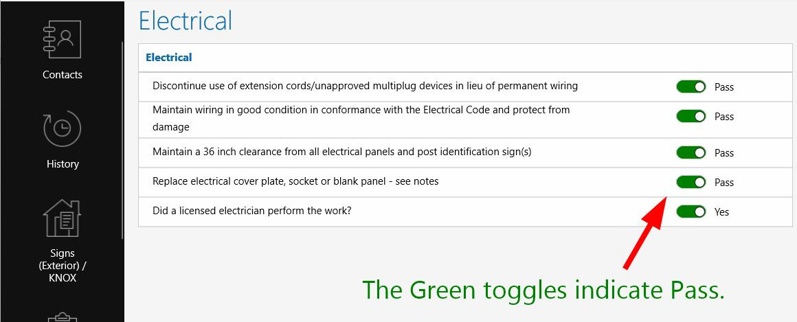

* 1. Likewise, if you uncheck the “Passed” box, Streamline will load the question to initially fail. Doing so requires the inspector to change the toggle to Pass/True/Yes if he wants to indicate that the response to the question is Pass/True/Yes. This is useful if the Administrator wants to ensure that the inspector addresses a question that requires a “True/Yes” response.

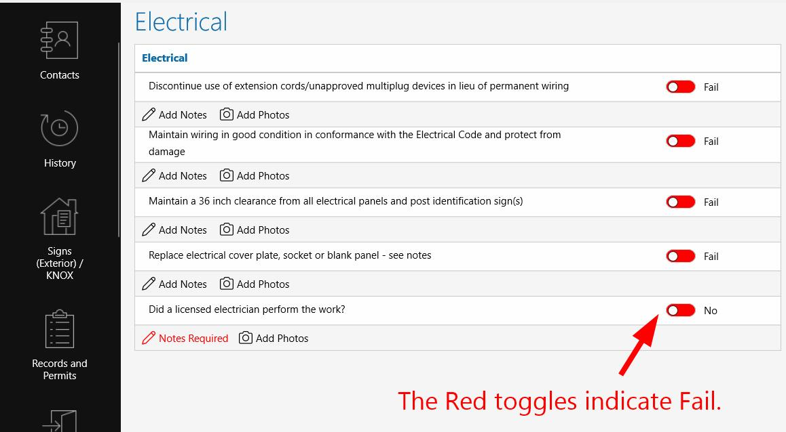

* 1. You want to check the “Editable” box so that the question will be Editable. Editable means that the inspector can interact with the controls associated with the inspection (toggle, slider, etc…) and can provide an answer.

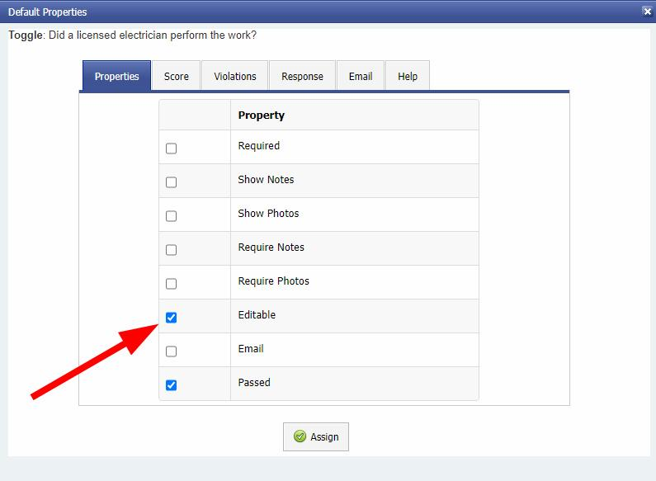

* 1. You can control the question’s text color with the “Required” checkbox.
     1. The text of the question will display as red or green if the “Required” textbox is checked and you have configured True and False Actions accordingly.

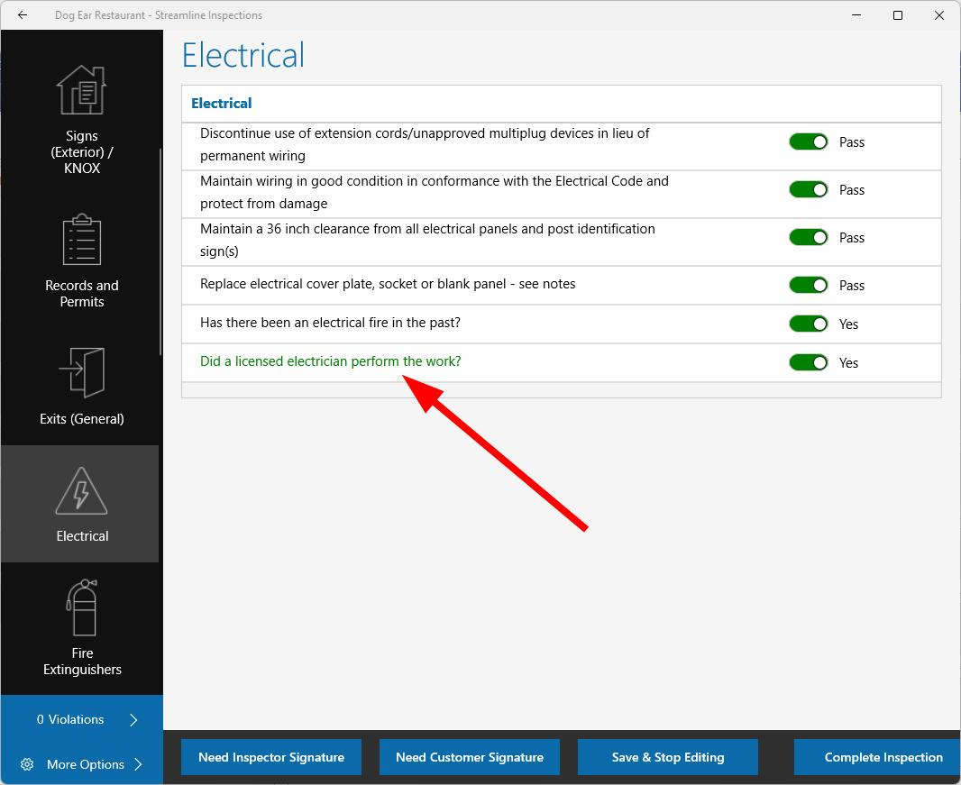

* + 1. See Required settings in “Configuring a True Response” and “Configuring a False Response” above.
  1. If you want to require the inspector to record a note, you would check both “Show Notes” and “Require Notes” in the Default Properties.
  2. If you want to require the inspector to capture a photo, you would check both “Show Photos” and “Require Photos.” Though these options are usually left unchecked in Default Properties because they are usually only necessary if the answer to the question is, “No,” (i.e. No, a licensed electrician did not perform the work.).
  3. If you check the “Email” box in Default Properties, an email will be sent as soon as the inspection is completed and synced if the inspector does not interact with the question. Again, you typically don’t want to check the “Email” box because emails are usually only necessary if the inspection issues a violation as a result of a NO/Fail answer.
* **You must also choose the proper response in the “Response” Tab.**

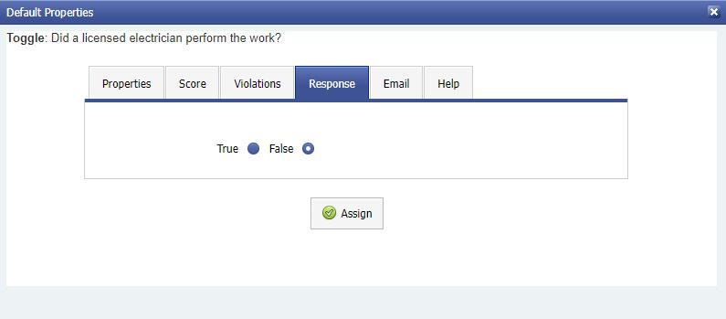

* 1. Check the proper box in the Response tab to match settings for your desired “true or false” answers.
     1. If you want the question to load as “Pass/Yes” and have already configured the Pass/Yes response in the True Response settings, check “True.” Doing so tells Streamline to apply the True settings to the initial appearance & function of the question when the inspection loads on the tablet.
     2. If you want the question to load as “Fail/No” and have already configured the Fail/No response in the False Response settings, check “False.” Doing so tells Streamline to apply the False settings to the initial appearance & function of the question when the inspection loads on the tablet.

### A very important note!!!

* + 1. If you want the question to initially load with a “Pass'' or “Yes” response, you must ensure that the checkboxes in the “Properties” tab in Default Properties match those on the “Properties” tab in the “True Actions” settings.

|  |  |
| --- | --- |

* + 1. And vice versa. If you want the question to initially load “No,” you must ensure that the checkboxes in the “Properties” tab of Default Properties match the checkboxes in the “Properties” tab of the False Actions settings.

|  |  |
| --- | --- |

* + 1. Failure to do so will result in a toggle that does not function properly.

### Adding a Violation to Appear on an Inspection Report

* **The “Violations” tab will allow you to specify a violation that will be recorded on the inspection report the event of a Fail/No response.**

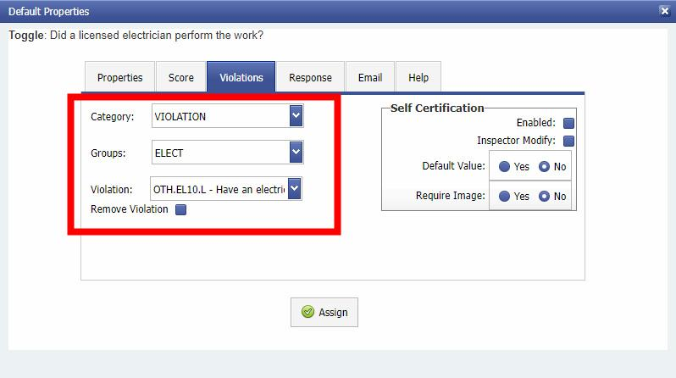

* 1. Select the Category of violation first (IFC 2018, CFC 2016, etc…).
  2. Once the Category settings have loaded, from the “Groups” dropdown box, select the section in which the violation appears (i.e. Electrical, Hazmat, etc…).
  3. Once the Groups settings have loaded, choose the Violation (i.e. 1201.2 Electrical Wiring and Equipment).
  4. This violation will be recorded on your inspection report when the question is recorded as a Fail/No response.
  5. Note: If no violation is entered in the “Violations” tab, no violation will be recorded on the inspection report, regardless of whether a “Fail/No” is marked on the tablet.

### Making a Violation a Self-Certification Violation

* **Self-Certification settings**
  1. To save the inspector from returning to an inspection site to reinspect a violation, Streamline allows Administrators and/or inspectors to designate violation repairs to be self-certified by the customer.
  2. You can set repairs to allow *Self-Certification* by checking the “Enable” checkbox in the Violations tab.

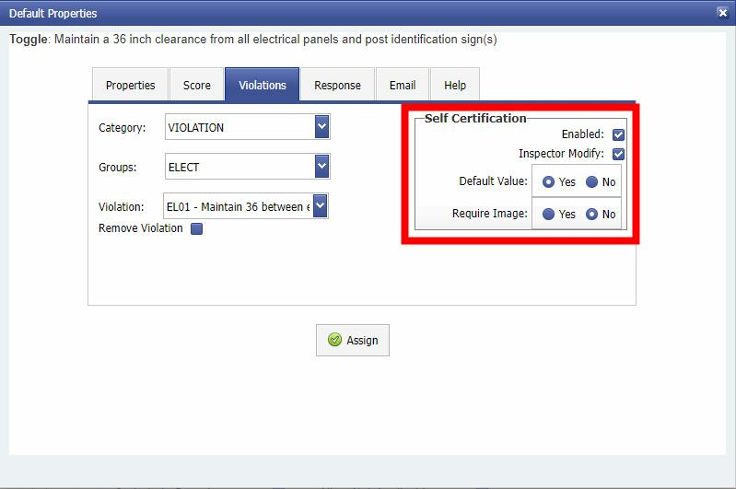

* 1. When the “Default Value” is set to Yes, Streamline initially loads the question to allow for self-certification of repaired violations. In this case, Streamline will not schedule a re-inspection for a violation pertaining to this question.
  2. Checking the “Inspector Modify” button will allow the inspector to redesignate the inspection violation as one that requires a reinspection (or vice versa). This change is performed by clicking on the violation text that appears under the question on the tablet.

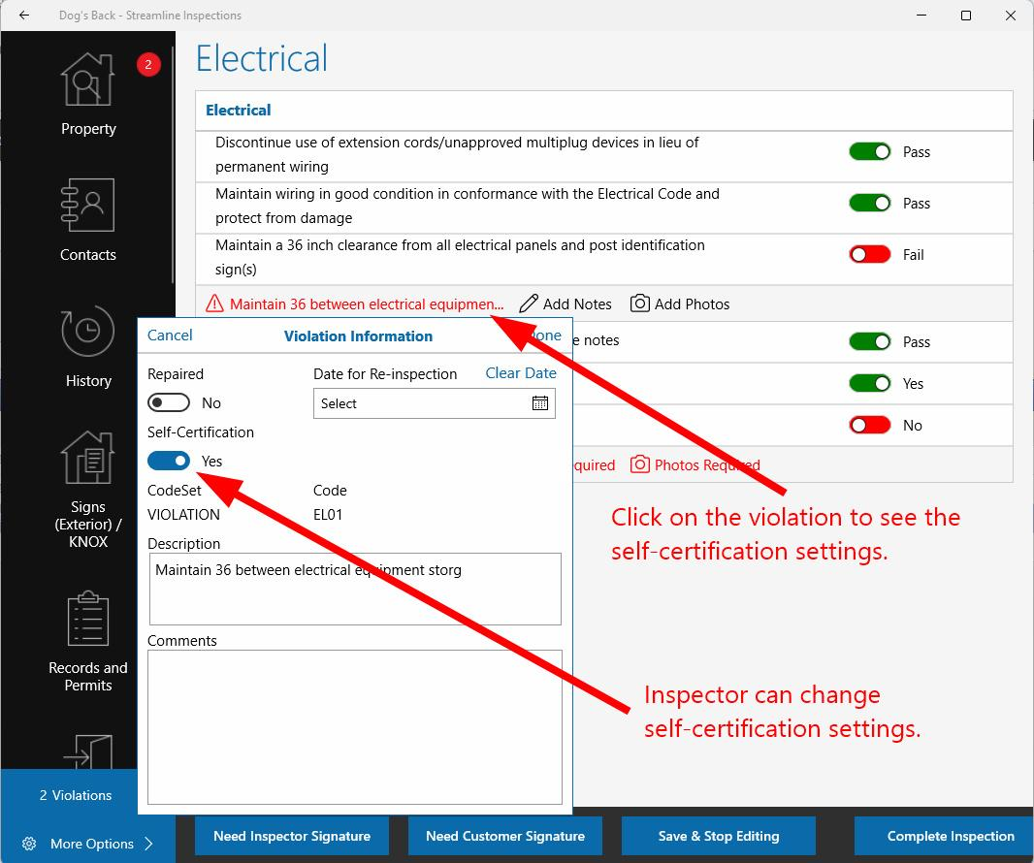

* 1. The “Require Image” checkbox indicates whether the customer must provide an image to prove that he/she has made the necessary repairs to clear the violation. The customer will upload the image on the customer portal. Check the box to require photographic proof.
* Email tab: The Email tab is used to send an email based upon a particular response to the question. For instance, on a “No” response, an email can be sent to the Fire Marshal or city attorney. From the dropdown box, select the name of the email template that contains the appropriate email recipient and the preconfigured email text.